Dear colleagues,

I would like to remind you that the registration for our ISW 2019 has already started!
Save your place and register now: https://iswreg.international.zcu.cz/

Best regards
Lucie Šmuclerová
E-mail: staffweek@rek.zcu.cz

International Staff Week at University of West Bohemia, Pilsen, Czech Republic
May 13 – 17, 2019
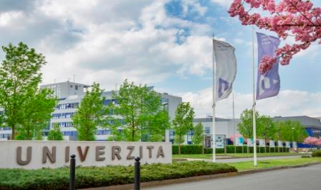
Language of the event: English
It is our pleasure to announce that we have set the date for our 2nd International Staff Week for academic and non-academic as well as library staff this year.
The International Office invites all our partner and non-partner universities to join 5-day programme at the UWB campus and the beautiful city of Pilsen.
The programme will consist of a mixture of meetings, presentations and workshops.
Two areas of networking:
1) International Office Staff and Mobility/Internationalisation Coordinators
Erasmus+ Credit Mobility & International Student Recruitment
2) Library Staff
Specialized workshops
The online registration form will be available from 01.02.2019 till 31.03.2019 on our website:
http://international.zcu.cz/en/
The International Staff Week will accept limited amount of participants. We will confirm to the registered applicants their participation after the registration deadline. Not later than the beginning of April 2019.

For more information, please don´t hesitate to contact us!
We look forward to meeting you at UWB, in Pilsen!

Yours sincerely,
International Office, University of West Bohemia
Lucie Šmuclerová
E-mail: staffweek@rek.zcu.cz

