Terms and Conditions of Open Run – Erasmus Run

- Aim of the competition:
- Promotion of Erasmus +Programme at Lublin University of Technology
- Integration of foreign students and LUT academic society and popularisation of running as the simplest way of movement and recreation among LUT's students and Staff
- The Organiser:
- Office of International Education of LUT
3. Time and place of the run
- the run will take place on Thursday, 10thOctober, 2019
- start and end will be situated near the Rectorat at 38D, Nadbystrzycka Street in Lublin
- the runs will begin from 9:00 am
- the map of the run:
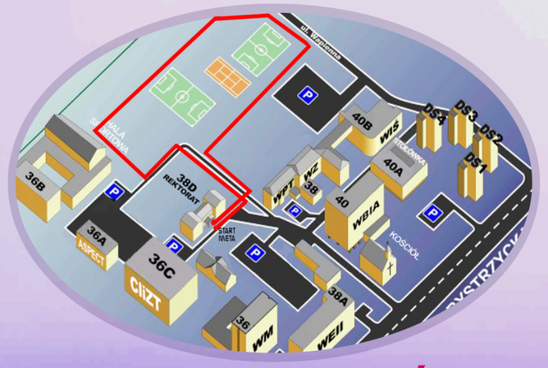
- participants in each category will run one lap.
4. Registration and start numbers
- the run is only for students and LUT Staff
- in order to register send an email to: m.gozdzik@pollub.pl
- registration should contain: name and surname and the category in which you want to take part
- it is possible to sign up 1 hour before the start of the run: from 7:00-8:00 at the office of OIE: Dormitory No4, room 6
- start numbers will be given to participants before the run at the organiser table.
5. Classification
- There will be the following classifications:
- students -women
- students -men
- staff -women
- staff -men
- The participant has to finish the race in order to be classified.
6. Rewards:
- The winners of 1st-2nd-3rd place in each category will receive diplomas and prize awards.
7. Final provisions
- Participation in the Open Run - Erasmus Run is possible only after signing the Participant’s Health and Accident Insurance Declaration.
- The run will be registered and photographed for documentation and promotional activities of LUT (The Organiser). Participation in the Run is equivalent to the agreement to using your image in photographic and film materials.
  - Your personal data (image) will be processed by Lublin University of Technology (LUT), on the basis of art. 13, par. 1 and 2 of the European Parliament and the Council Order 2016/679 of 27 April 2016 on personal data protection and free data movement, repealing the 95/46/WE Directive (general data protection act) (Dz. Urz. [EU Journal of Laws] L 119 of 04.05.2016, p. 1), hereinafter referred to as RODO and Personal Data Protection Act of 9 May 2018 (Dz. U. [Journal of Laws] of 2018 item 1000 as amended). Your personal data will be processed and kept until final settling of the Erasmus+ project.
  - The administrator of your personal data is Lublin University of Technology (LUT), Nadbystrzycka 38D, 20-618 Lublin
  - Tomasz Joński is the Data Protection Officer at Lublin University of Technology, email: t.jonski@pollub.pl
  - You have the right to access your personal data and to correct, delete, limit, process your personal data as well as the right to data portability. You have the right to withhold your consent at any time with no effect on the lawfulness of data processing.
  - Should you consider your personal data being processed in violation with the Personal Data Protection Act of 27 April 2016, you have the right to lodge a complaint to the competent supervisory body, that is the Head of the Office for the Data Protection.
  - Accepting the Terms and Conditions is equivalent to giving consent to processing your personal data in connection with the organisation of the Open Run – Erasmus Run. Accepting the Terms and Conditions is the condition to participate in the Run.
  - Data processing for marketing purposes will be possible only with additional consent from the Participant.
- The participant takes part in the Run solely on their own responsibility and bears the risks connected with it.
- The participant is solely responsible for the accident insurance.
- The Organiser is not responsible for left and lost belongings.
- The Organiser settles the cases not covered by these Terms and Conditions.

